# 

# Features Of The App

Tigerr App For IOS

By Michael Ubah

|  |  |  |  |  |  |
| --- | --- | --- | --- | --- | --- |
| Connect with Pet owners and lovers alike through Tigerr's fluid user interface and wide range of features!  Discuss pets of all kinds with users across the globe, including: Dogs, Cats, Birds, Rabbits, Rodents, Horses, Aquarium (fish), Reptiles, Amphibians, Insects and Spiders.  10 categories of Discussion to cover all essential topics in a very uniform and tidy way: General, Advice & Help, Nutrition, Training, Adoption, Breeding, Charity & Rescue, Lost and Products.  Upload your pet images to the gallery and search through the large collection of funny and cute pet images, saving your favorites to revisit and share with friends.  For users who have, are thinking of obtaining, or are interested in pets, Tigerr is the final stop for all your needs! |  | |  | | --- | | App uses Firebase Firestore for its database needs, Firebase Storage for storing uploaded images, and Firebase Authentication to create and sign in users.  App includes a profile page from which to track the users uploaded images and created topics, as well as a hold to delete function for individual topics/images.  An admin portal for dealing with reported topics, images, or replies, from which the admin can delete the reported post if necessary and disable the user.  A double tap to like feature on images, similar to Instagram.  Custom transition animations between view controllers, one ported from github and adapted for the project, one created by me.  Fully functional liking, disliking, commenting and reputation giving system.  Ranks e.g “Newcomer”, “Top Poster” etc, dependent on number of topics created by user and number of replies made. | |  | |  | |

# Screenshots of the app development

*Screenshot of Tigerr’s Main.storyboard*

*Screenshot of Upload to Gallery Code snippet*

*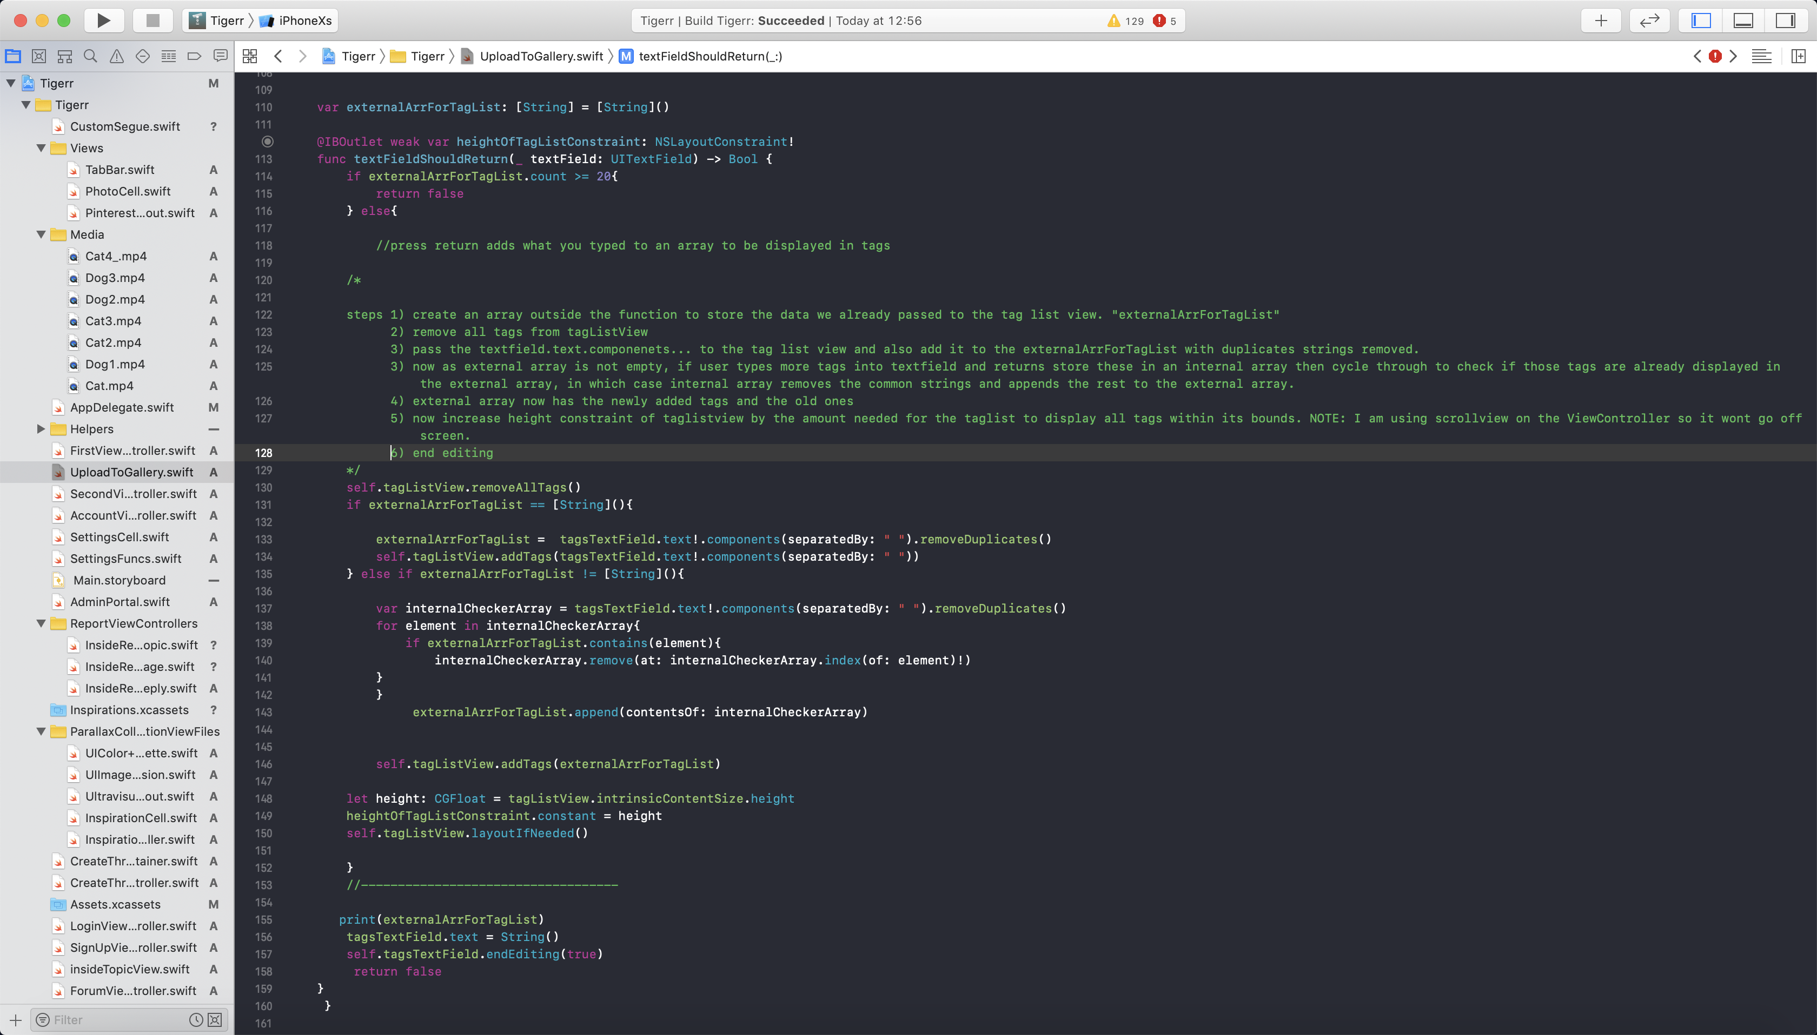Screenshot of Upload to Gallery Code snippet (creating tags for the image)*